Bahria University,

Karachi Campus



LAB EXPERIMENT NO.

___01___

LIST OF TASKS

|  |  |
| --- | --- |
| TASK NO | OBJECTIVE |
| **01** | **Get Order id, Product id, Unit price from Order Details.** |
| **02** | **Find Title of employee Nancy.** |
| **03** | **Display data of all employees those working as Sales Representative from London** |
| **04** | **Display product name whose unit price are greater than 90$** |
| **05** | **Write a query to get current Product list (Product ID and name).** |
| **06** | **Fetch data of customers where country is "Germany" AND city must be "Berlin" OR "München" (use parenthesis to form complex expressions)** |
| **07** | **Fetch data of customers from all countries except Germany and USA** |
| **08** | **Fetch Discontinued products who’s price is greater than 20** |
| **09** | **Get the price of an order (by multiplying unit price by quantity).** |
| **10** | **Display all cities that employees belong to but do not allow repetition.** |
| **11** | **Find complete name of all employees.** |
| **12** | **Display all the orders where unit price list in the range of 10$ to 40$.** |
| 13 | List all products where UnitPrice is not in 10,12,15,17 or 19. |

Submitted On:

01-03-2023

(Date: DD/MM/YY)

**Task 01:** Get Order id, Product id, Unit price from Order Details.

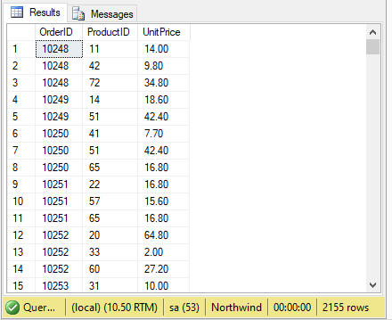**Solution:** select OrderID,ProductID,UnitPrice from [Order Details]

**Output:**

**Task 02:** Find Title of employee Nancy

**Solution:** select Title from Employees

**Output:**

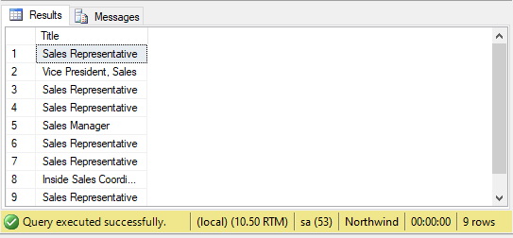

**Task 03:** Display data of all employees those working as Sales Representative from London

**Solution:** select * from Employees where Title='Sales Representative' AND City='London'

**Output:**

**Task 04:** Display product name whose unit price are greater than 90$

**Solution:** select ProductName from Products where UnitPrice > 90

**Output:**

**Task 05:** Write a query to get current Product list (Product ID and name).

**Solution:** select * from Products where Discontinued='0'

**Output:**

**Task 06:** Fetch data of customers where country is "Germany" AND city must be "Berlin" OR "München" (use parenthesis to form complex expressions)

**Solution:** select * from Customers where Country='Germany' AND (City='Berlin' OR City='München')

**Output:**

**Task 07:** Fetch data of customers from all countries except Germany and USA

**Solution:** select * from Customers where Country!='Germany' AND Country!='USA'

**Output:**

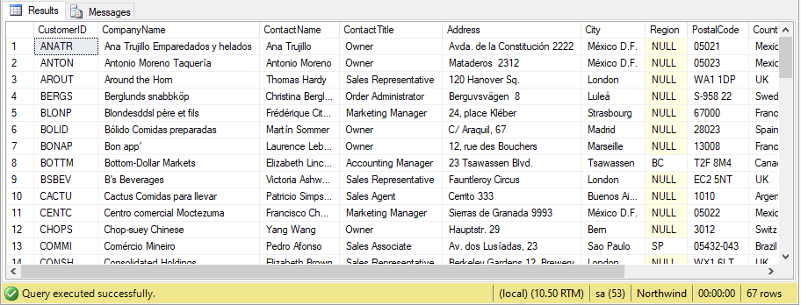

**Task 08:** Fetch Discontinued products who’s price is greater than 20

**Solution:** select * from Products where Discontinued='1' AND UnitPrice>20

**Output:**

**Task 09:** Get the price of an order (by multiplying unit price by quantity).

**Solution:** select UnitPrice*Quantity As Price from [Order Details]

**Output:**

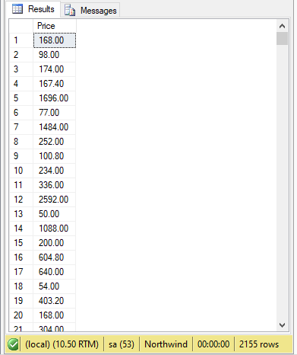

**Task 10:** Display all cities that employees belong to but do not allow repetition.

**Solution:** select distinct City from Employees

**Output:**

**Task 11:** Find complete name of all employees.

**Solution:** select FirstName+LastName as FullName from Employees

**Output:**

**Task 12:** Display all the orders where unit price list in the range of 10$ to 40$.

**Solution:** select * from [Order Details] where UnitPrice BETWEEN 10 AND 40

**Output:**

**Task 13:** List all products where UnitPrice is not in 10,12,15,17 or 19.

**Solution:** select * from Products where UnitPrice NOT IN (10,12,15,17)

**Output:**